1. **Data Import**
2. Download **northwind-db.sql** from classroom
3. Open XAMPP and Click **Explorer**
4. Copy downloaded database to **mysql** folder.
5. Open Shell from XAMPP Admin Panel.
6. Create database **<yourname>northwind** and exit

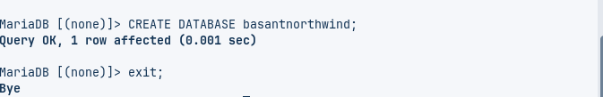

1. Import database in **<yourname>northwind** using following command at SHELL **Query:**

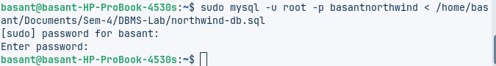

1. Connect to database using command **mysql -u root -p**

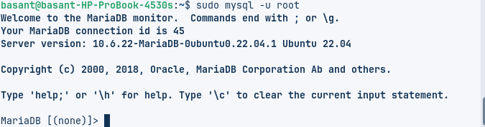

1. Use **<yourname>northwind** database using
   1. QUERY:

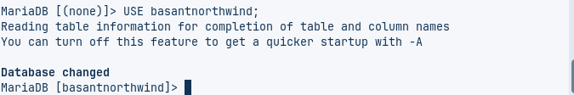

* 1. QUERY:  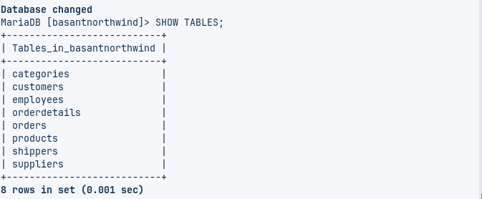
  2. Check attributes and constraints in each tables i.e. **DESCRIBE <tablename>**

Customers  
 QUERY:

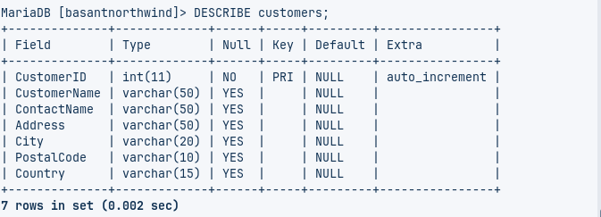

Employees

QUERY:

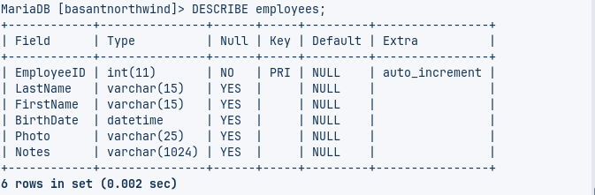

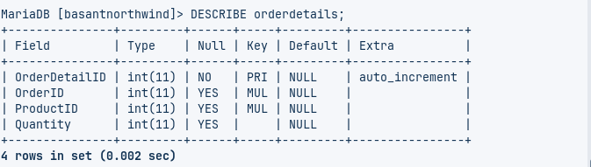Orderdetails  
 QUERY:

Orders  
 QUERY:

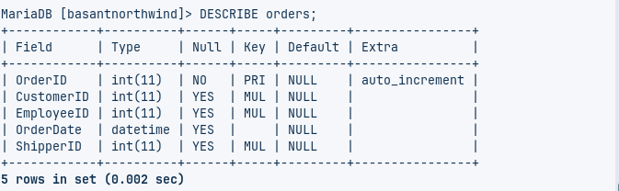

Products  
 QUERY:

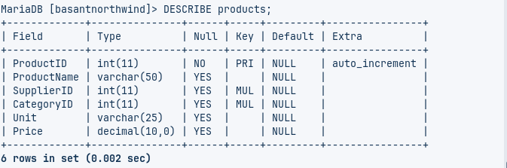

Shippers  
 QUERY:

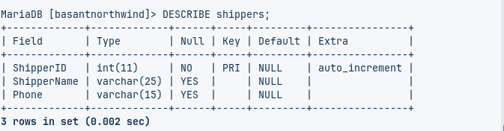

Suppliers  
 QUERY:

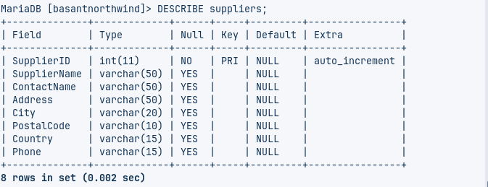

1. **Data QUERY Languages (DQL)**
2. Project CategoryName from categories  
    QUERY:

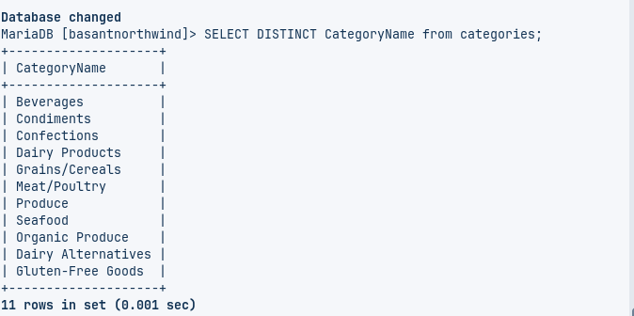

1. Project country from customers  
    QUERY:

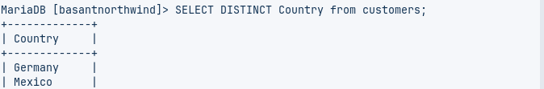  
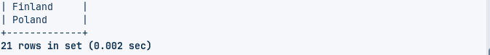

1. Project city, country from customers  
    QUERY:

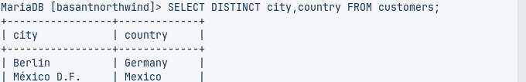

1. SELECT CustomerName from customers who are from Madrid City  
    QUERY:

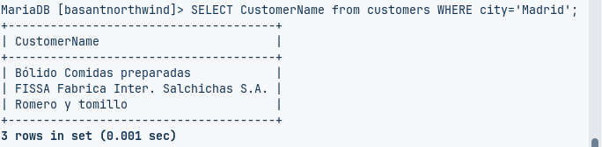

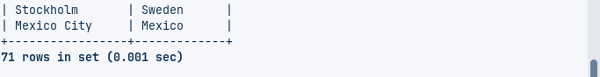

5. SELECT CustomerID from customers who are from Germany

QUERY:

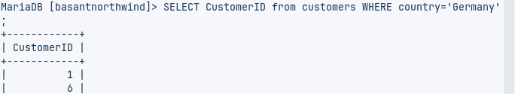

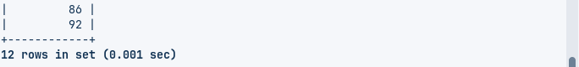

6. SELECT CustomerID, CustomerName from customers who are from Germany or Spain

QUERY:

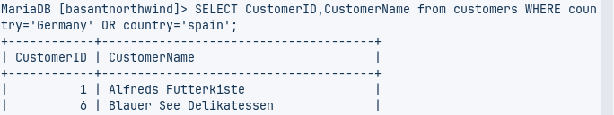

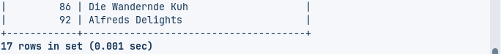

7. SELECT all from customers who are from London and UK  
 QUERY:

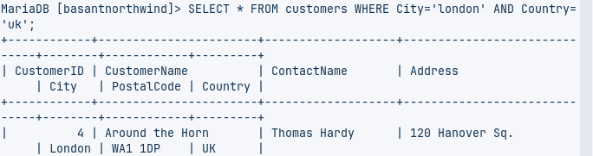

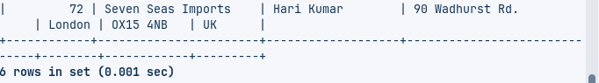

8. SELECT all from customers who are from city having names that start with first letter of Your Name.  
 QUERY:

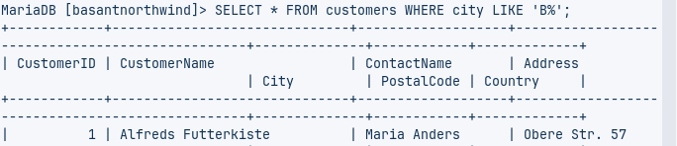

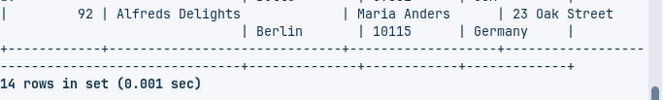

1. SELECT all from customers who are not from Canada and Belgium

QUERY:

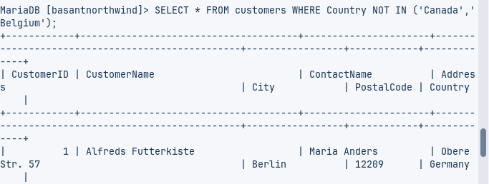

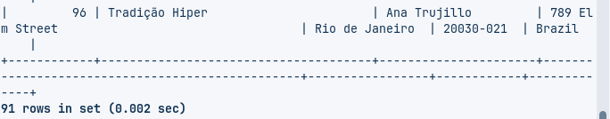

1. SELECT all from customers who are from G7 Countries  
    QUERY:

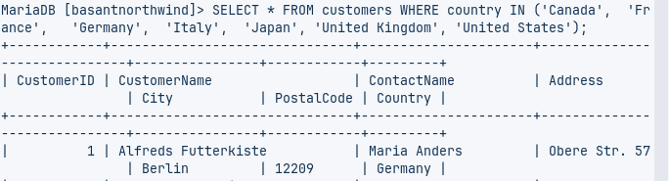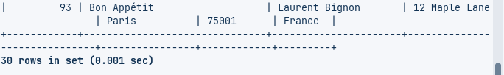

1. SELECT all from customers who have PostalCode containing 31  
    QUERY:

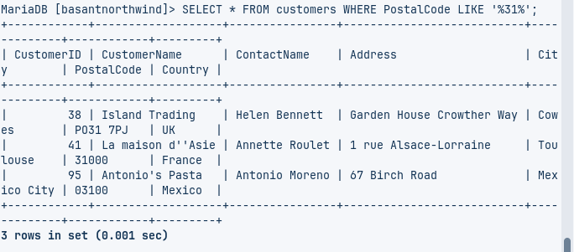

1. SELECT all from customers having PostalCode containing 00 and from Rome or Paris.

QUERY:

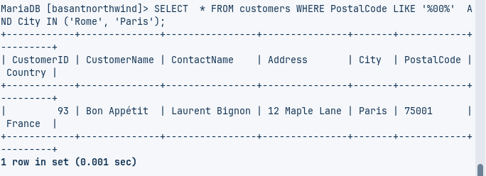

1. SELECT all from customers who are not from Salzburg

QUERY:

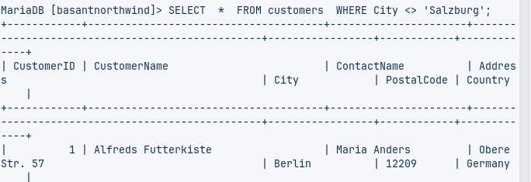

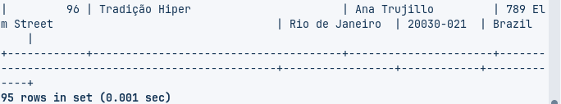

1. SELECT all employees who are born on July  
     
    QUERY:

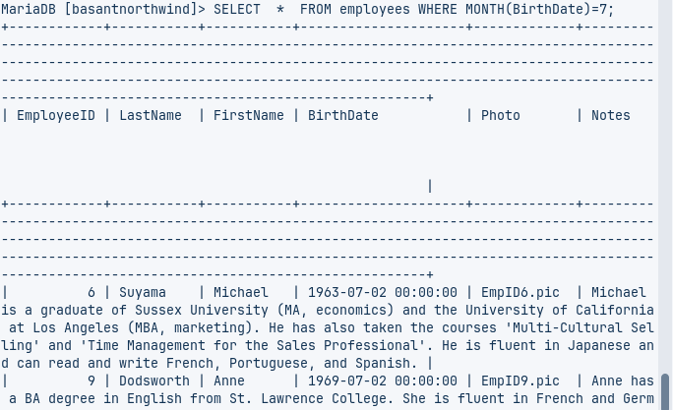

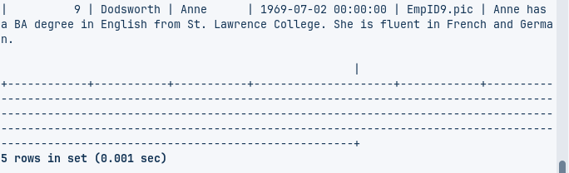

1. SELECT all employees having BA degree in Notes  
     
   QUERY:

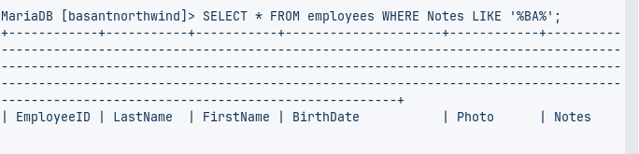

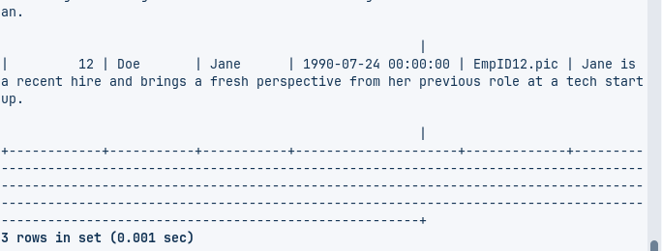

1. SELECT all suppliers from USA and Japan

QUERY:

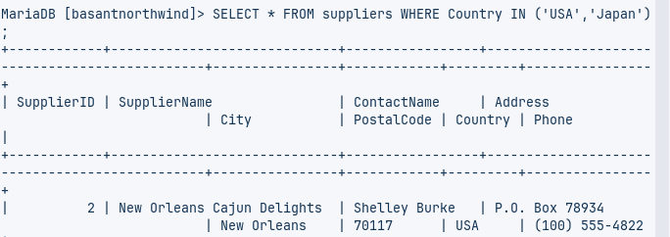 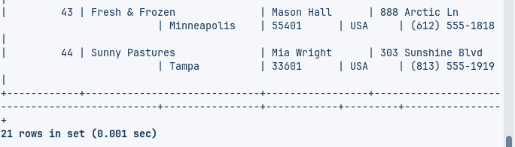

1. Find name and count of suppliers from different countries.

QUERY:

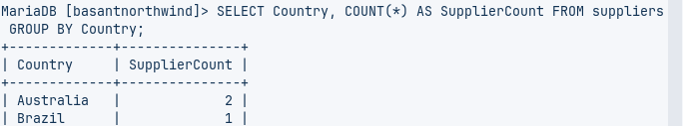

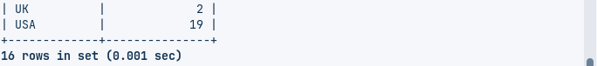

1. Find name and count of customers from different cities.  
    Query:

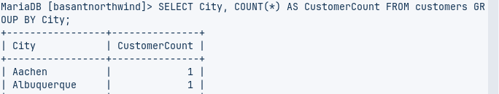

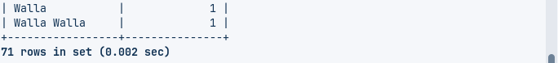

1. Find number of orders made by employee along with employeeID.

Query:

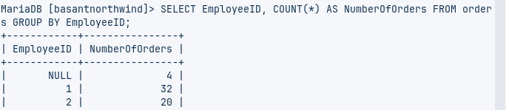

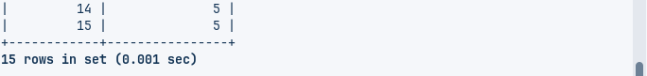

1. Find number of orders made by customers along with customerID

Query:

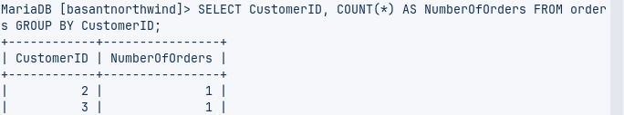

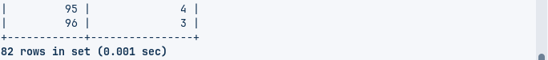

1. Find all order that are shipped by shippers having 1 or 3 shipperID  
    Query:

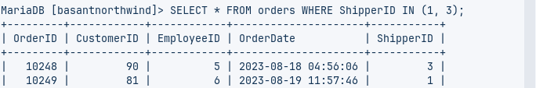

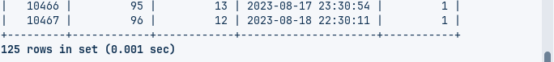

1. SELECT all product having categoriesID 1  
    Query:

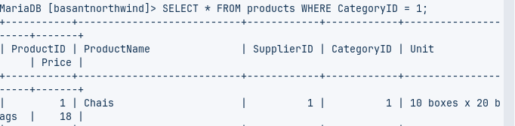

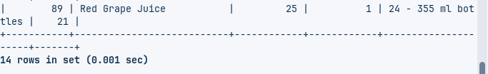

1. SELECT all products having ProductName that starts with First Letter of your name.  
    Query:

